**Mystery**

***Stego***

**Challenge:**

Hidden within this image is a concealed message, waiting to be unraveled. The key to unlock the mystery lies in the heart of our theme. Can you discover the hidden treasure without a password?

Attached - pirate.jpg

**Approach:**

We see a jpg in a steganography challenge and head up to use stegseek and get successful with getting another image pirate.jpg.out.

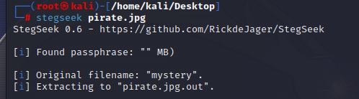

We use exiftool on this image to get this Image unique ID:

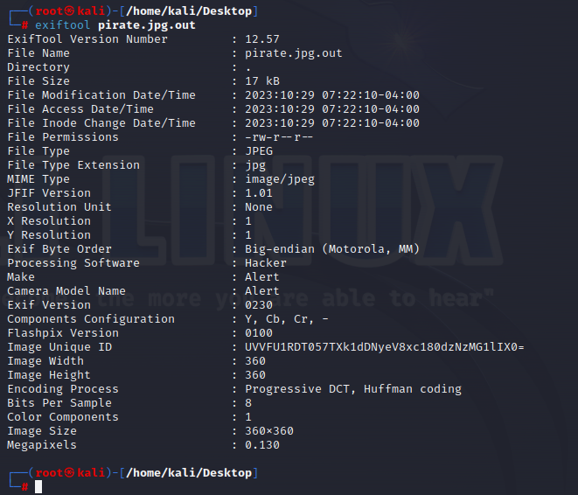

Base64 decode that and we get our flag:

**Flag: QUESTCON{My5t3ry_1s_4w3s0me!}**

Congrats!!

Happy Hacking!